EXPERIMENT 5: Out of Boundary Paths

Aim:
To write a Python program to find the number of paths that move out of the boundary of a grid within a given number of moves using dynamic programming.

Algorithm:
- Start.
- Define the number of rows and columns of the grid.
- Define the maximum number of moves and the starting position.
- Store the number of ways to reach each cell.
- For every move, try moving in four directions: up, down, left, and right.
- If a move goes outside the grid boundary, increase the path count.
- Otherwise, store the number of ways for the new cell.
- Repeat until the maximum number of moves is reached.
- Display the total number of paths that move outside the boundary.
- Stop.

Source Code:
def find_paths(m, n, max_move, start_row, start_column):
MOD = 1000000007

# dp[i][j] represents number of ways to reach cell (i, j)
dp = [[0] * n for _ in range(m)]
dp[start_row][start_column] = 1

result = 0

directions = [
(-1, 0), # Up
(1, 0), # Down
(0, -1), # Left
(0, 1) # Right
]

for move in range(max_move):
new_dp = [[0] * n for _ in range(m)]

for i in range(m):
for j in range(n):
if dp[i][j] == 0:
continue

for di, dj in directions:
ni = i + di
nj = j + dj

if ni < 0 or ni >= m or nj < 0 or nj >= n:
result = (result + dp[i][j]) % MOD
else:
new_dp[ni][nj] = (
new_dp[ni][nj] + dp[i][j]
) % MOD

dp = new_dp

return result

# Input values
m = 2
n = 2
max_move = 2
start_row = 0
start_column = 0

result = find_paths(m, n, max_move, start_row, start_column)

print("Grid Size:", m, "x", n)
print("Maximum Moves:", max_move)
print("Starting Position:", (start_row, start_column))
print("Number of Paths Out of Boundary:", result)

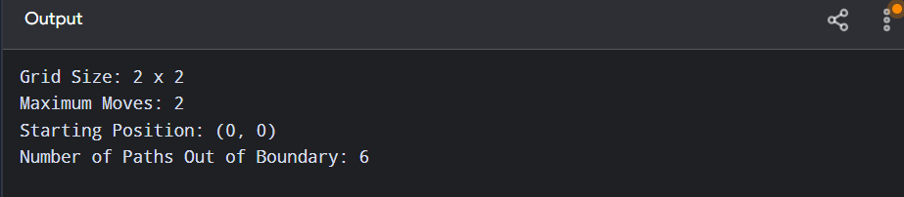

Result:
Thus, the Out of Boundary Paths problem was successfully implemented using dynamic programming, and the number of paths leaving the grid boundary was obtained.

